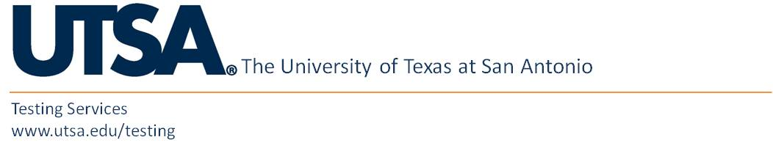

Testing Services Office
MS 1.01.04 One UTSA Circle, San Antonio, TX 78249
(210) 458-4125

Payment of Testing Fees
Credit: TS16 Date:
DUX012 60305

Student Last Name:
Student First Name:
Student ID #:

Paid $80 for a Competency Based Exam (TS16)
for credit in: Receipt No.:
(list course no.)

ALL FEES ARE NON-REFUNDABLE

Fiscal Services Validation:

Photo I.D. Required Before Testing Admittance:
Absolutely no admission allowed without valid (non-expired) photo I.D.

